23CSE203
Data Structures and Algorithms
LAB MANUAL



Submitted by
Name | N.MANIKANTA GOWTHAM
Roll No | AV.SC.U4CSE24231
Year/Sem/Section | 2nd Year/3rd Sem/CSE-C
Date of Submission
Submitted to
Name | Dr Thulasi Bikku
Department | CSE
Designation | Professor

INDEX
S.NO | TITLE | PAGE.NO | SIGNATURE
1. | Array Operations  Objective: Implement array operations .  Tasks:  •Write a Python program to:  - Traverse a list and print all elements.  - Insert an element at a given index (shift elements using list slicing).  - Delete an element at a given index (remove and shift).  - Search for an element using linear search (return index or -1).  - Update an element at a given index.  •Test with input list [5, 3, 8, 1, 9]; insert 7 at index 2, delete index 1, search 8, update index 3 to 4. | 4-5
2. | Singly Linked List and Stack  Objective: Build linked lists and stack operations.  Tasks:  •Implement a singly linked list in Python with a Node class (data, next) and methods:  - Insert at front and end.  - Delete at front and traverse.  •Implement a stack using a linked list with push, pop, peek, and is_empty.  •Test linked list: insert [10, 20, 30], delete front. Test stack: push [5, 10], pop once, peek | 6-9
3. | Queue Implementations  Objective: Implement queue variants.  Tasks:  •Implement in Python:  - Array-based queue using a list with enqueue, dequeue, and front.  - Circular queue (list-based) handling wrap-around.  •Test with: enqueue [10, 20, 30], dequeue twice, enqueue 5 in circular queue. | 10-13
4. | Sorting Algorithms  Objective: Implement and compare sorting algorithms.  Tasks:  •Implement insertion sort and merge sort in Python.  •Compare performance using time module on a random list of 50 integers.  •Test with input: [64, 34, 25, 5, 22]. | 14-15
5. | Binary Search Tree and Traversals  Objective: Code tree traversals and BST operations.  Tasks:  •Implement a binary tree in Python with a Node class and: Inorder traversal.  •Implement a BST with insert, search, and delete (handle leaf and one-child cases).  •Test with: insert [50, 20, 70], search 20, delete 20, print inorder traversal. | 16-18
6. | Heap and Priority Queue  Objective: Implement heap-based priority queues .  Tasks:  •Implement a min-heap in Python using a list with: Insert, extract-min, and heapify (use heapq optionally).  •Implement heapsort using min-heap.  •Test with: [4, 30, 3, 25, 16, 9]. | 19-20
7. | Hash Table Implementation  Objective: Code hash tables with collision handling.  Tasks:  •Implement a hash table in Python with: Open addressing (linear probing) using a list.  •Test with: insert keys [12, 44, 13, 88, 23], search 44,delete13. | 21-22
8. | B-Tree Implementation  Objective: Implement B-trees for indexing.  Tasks:  •Implement a B-tree in Python (order m=3) with: Insert and search operations.  •Test with: insert [10, 20, 5, 6, 12, 30], search 6. | 23-25
9. | Graph Representation and Traversals  Objective: Implement graph representations and traversals.  Tasks:  •Implement a graph in Python using an adjacency list (dictionary of lists).  •Implement depth-first search (DFS) and breadth-first search (BFS).  •Test with graph: nodes [A, B, C, D], edges [A-B, B-C, C-D, A-D]. | 26-28
10. | Dijkstra’s and Bloom Filter  Objective: Implement shortest path algorithm and advanced data structure.  Tasks:  •Implement Dijkstra’s algorithm in Python for shortest paths using heapq.  •Implement a Bloom filter with multiple hash functions (hashlib) for membership testing.  •Test Dijkstra’s with graph: nodes [A, B, C, D], edges [A-B:4, A-C:2, B-D:5, C-D:8]. Test Bloom filter with: insert [apple, banana], query [apple, orange]. | 29-31

LAB-1

AIM-Array Operations
Objective: Implement array operations.
Tasks:
•Write a Python program to:
- Traverse a list and print all elements.
- Insert an element at a given index (shift elements using list slicing).
- Delete an element at a given index (remove and shift).
- Search for an element using linear search (return index or -1).
- Update an element at a given index.
•Test with input list [5, 3, 8, 1, 9]; insert 7 at index 2, delete index 1, search 8,
update index 3 to 4.

DESCRIPTION- This program implements fundamental array operations using Python lists, which act as dynamic arrays. Arrays are sequential data structures that store multiple elements of the same or different data types and allow direct access using indices.
The program performs basic operations such as traversing, inserting, deleting, searching, and updating elements to demonstrate how arrays are accessed and modified in memory.

PROGRAM-
def traverse(arr):
for elem in arr:
print(elem, end=" ")
print()

def insert(arr, index, value):
return arr[:index] + [value] + arr[index:]

def delete(arr, index):
return arr[:index] + arr[index+1:]

def linear_search_range(arr, value):
for idx in range(len(arr)):
if arr[idx] == value:
return idx
return -1

def update(arr, index, value):
arr[index] = value
return arr

# --------- User Input Section ---------
# Initial array
lst = list(map(int, input("Enter list elements separated by space: ").split()))
print("Original list:")
traverse(lst)

# Insert
index = int(input("Enter index to insert: "))
value = int(input("Enter value to insert: "))
lst = insert(lst, index, value)
print(f"After inserting {value} at index {index}:")
traverse(lst)

# Delete
del_index = int(input("Enter index to delete: "))
lst = delete(lst, del_index)
print(f"After deleting element at index {del_index}:")
traverse(lst)

# Linear search
search_value = int(input("Enter value to search: "))
idx_range = linear_search_range(lst, search_value)
print(f"Index of {search_value} (using range): {idx_range}")

# Update
update_index = int(input("Enter index to update: "))
update_value = int(input("Enter new value: "))
lst = update(lst, update_index, update_value)
print(f"After updating index {update_index} to {update_value}:")

traverse(lst)
print("Manikanta - 24231")

OUTPUT-
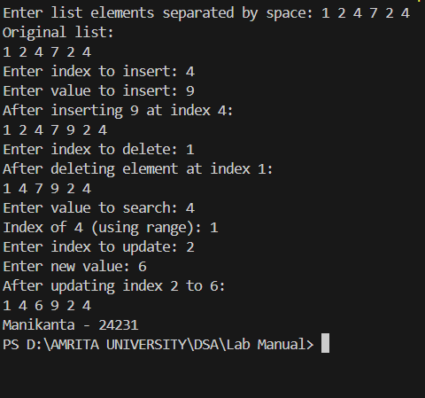

CONCLUSION- By performing traversal, insertion, deletion, searching, and updating, it shows how data within an array can be efficiently accessed and modified. Through this exercise, we gain a better understanding of how arrays manage memory and handle element shifting forming a foundation for learning more advanced data structures like linked lists and stacks.
LAB-2

AIM-Singly Linked List and Stack
Objective: Build linked lists and stack operations.
Tasks:
•Implement a singly linked list in Python with a Node class (data, next) and methods:
- Insert at front and end.
- Delete at front and traverse.
•Implement a stack using a linked list with push, pop, peek, and is_empty.
•Test linked list: insert [10, 20, 30], delete front. Test stack: push [5, 10], pop once, peek.

DESCRIPTION- a singly linked list and a stack using linked lists in Python. The linked list implementation includes a Node class that stores a data element and a reference to the next node. The linked list supports insertion at both the front and end, deletion from the front, and provides a method to traverse and display its contents.
In addition, stack operations (push, pop, peek, and is_empty) are implemented on top of the singly linked list. The stack uses the linked list’s front as the top of the stack, enabling efficient push and pop operations.

PROGRAM-
class Node:
def __init__(self, data):
self.data = data
self.next = None

class LinkedList:
def __init__(self):
self.head = None

def add_first(self, data):
new_node = Node(data)
new_node.next = self.head
self.head = new_node

def add_last(self, data):
new_node = Node(data)
if not self.head:
self.head = new_node
return
curr = self.head
while curr.next:
curr = curr.next
curr.next = new_node

def del_first(self):
if not self.head:
print("List is empty! Cannot delete.")
return
print(f"Deleted from front: {self.head.data}")
self.head = self.head.next

def print_list(self):
curr = self.head
if not curr:
print("List is empty.")
return
print("Linked List: ", end="")
while curr:
print(curr.data, end=" -> ")
curr = curr.next
print("None")

class Stack:
def __init__(self):
self.top = None

def is_empty(self):
return self.top is None

def push(self, data):
new_node = Node(data)
new_node.next = self.top
self.top = new_node
print(f"Pushed: {data}")

def pop(self):
if self.is_empty():
print("Stack is empty! Cannot pop.")
return None
popped_data = self.top.data
self.top = self.top.next
print(f"Popped: {popped_data}")
return popped_data

def peek(self):
if self.is_empty():
print("Stack is empty! Nothing to peek.")
return None
print(f"Top element: {self.top.data}")
return self.top.data

def display(self):
curr = self.top
if not curr:
print("Stack is empty.")
return
print("Stack (top -> bottom): ", end="")
while curr:
print(curr.data, end=" -> ")
curr = curr.next
print("None")

def main():
print("=== Singly Linked List Operations ===")
ll = LinkedList()
n = int(input("How many elements to insert at front? "))
for i in range(n):
val = int(input(f"Enter value {i + 1} to insert at front: "))
ll.add_first(val)
ll.print_list()

m = int(input("How many elements to insert at end? "))
for i in range(m):
val = int(input(f"Enter value {i + 1} to insert at end: "))
ll.add_last(val)
ll.print_list()

print("\nDeleting the front node...")
ll.del_first()
ll.print_list()
print("Traversing linked list:")
ll.print_list()

print("\n=== Stack Operations Using Linked List ===")
stack = Stack()
p = int(input("How many elements to push onto stack? "))
for i in range(p):
val = int(input(f"Enter value {i + 1} to push: "))
stack.push(val)
stack.display()

print("\nPerforming one pop operation from stack...")
stack.pop()
stack.display()

print("\nPeeking top element of the stack...")
stack.peek()

if __name__ == "__main__":
main()
print("Manikanta - 24231")

OUTPUT-
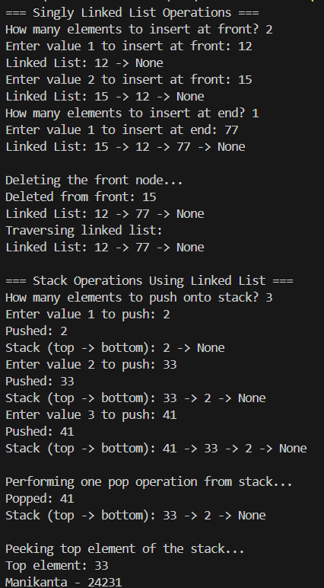

CONCLUSION- Implementing singly linked lists and stack data structures in Python demonstrates a core understanding of pointer manipulation and dynamic memory management. The testing showed that insertions and deletions work correctly in the linked list, and standard stack operations using the linked list are effective. This exercise reinforced the differences in operational mechanics between linked lists and stacks, highlighting how stacks can be efficiently constructed using linked lists, and how both structures support dynamic growth and contraction during runtime.

LAB-3
AIM-
Queue Implementations
Objective: Implement queue variants.
Tasks:
•Implement in Python:
- Array-based queue using a list with enqueue, dequeue, and front.
- Circular queue (list-based) handling wrap-around.
•Test with: enqueue [10, 20, 30], dequeue twice, enqueue 5 in circular queue.

DESCRIPTION-
- Array-Based Queue: This queue uses a Python list to store elements in a first-in, first-out (FIFO) manner. It supports the core operations: enqueue (insert at the rear), dequeue (remove from the front), and front (peek at the element at the front). The front and rear indices are updated with each operation.

- Circular Queue: This variant uses a fixed-size list and ensures efficient use of space by allowing the front and rear pointers to wrap around when the end of the list is reached (the "circular" effect). Like the standard queue, it includes enqueue, dequeue, and front methods. Special care is taken to check for full and empty states and handle pointer incrementing with modulo arithmetic for wrap-around.

PROGRAM-
class ArrayQueue:
def __init__(self):
self.queue = []

def enqueue(self, data):
self.queue.append(data)
print(f"Enqueued: {data}")

def dequeue(self):
if self.is_empty():
print("Queue is empty! Cannot dequeue.")
return None
removed = self.queue.pop(0)
print(f"Dequeued: {removed}")
return removed

def front(self):
if self.is_empty():
print("Queue is empty!")
return None
print(f"Front element: {self.queue[0]}")
return self.queue[0]

def is_empty(self):
return len(self.queue) == 0

def display(self):
print("Array Queue:", self.queue if self.queue else "Empty")

class CircularQueue:
def __init__(self, size):
self.size = size
self.queue = [None] * size
self.front = self.rear = -1

def is_empty(self):
return self.front == -1

def is_full(self):
return (self.rear + 1) % self.size == self.front

def enqueue(self, data):
if self.is_full():
print("Circular Queue is full! Cannot enqueue.")
return
if self.is_empty():
self.front = 0
self.rear = (self.rear + 1) % self.size
self.queue[self.rear] = data
print(f"Enqueued: {data}")

def dequeue(self):
if self.is_empty():
print("Circular Queue is empty! Cannot dequeue.")
return None
removed = self.queue[self.front]
if self.front == self.rear:
self.front = self.rear = -1
else:
self.front = (self.front + 1) % self.size
print(f"Dequeued: {removed}")
return removed

def front_elem(self):
if self.is_empty():
print("Circular Queue is empty!")
return None
print(f"Front element: {self.queue[self.front]}")
return self.queue[self.front]

def display(self):
if self.is_empty():
print("Circular Queue: Empty")
return
print("Circular Queue:", end=" ")
i = self.front
while True:
print(self.queue[i], end=" ")
if i == self.rear:
break
i = (i + 1) % self.size
print()

def main():
print("=== Array-based Queue ===")
aq = ArrayQueue()
n = int(input("Enter total elements to enqueue: "))
for i in range(n):
val = int(input(f"Enter value {i+1} to enqueue: "))
aq.enqueue(val)
aq.display()

d = int(input("How many elements to dequeue? "))
for i in range(d):
aq.dequeue()
aq.display()
aq.front()

print("\n=== Circular Queue ===")
size = int(input("Enter size of circular queue: "))
cq = CircularQueue(size)
n2 = int(input("Enter total elements to enqueue: "))
for i in range(n2):
val = int(input(f"Enter value {i+1} to enqueue: "))
cq.enqueue(val)
cq.display()

d2 = int(input("How many elements to dequeue? "))
for i in range(d2):
cq.dequeue()
cq.display()

wrap_val = int(input("Enter one value to enqueue for wrap-around test: "))
cq.enqueue(wrap_val)
cq.display()
cq.front_elem()

if __name__ == "__main__":
main()
print("Manikanta - 24231")

OUTPUT-
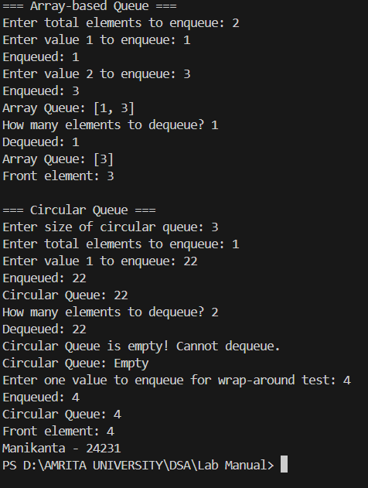

CONCLUSION- The array-based queue is simple but can waste memory as elements are removed. In contrast, the circular queue makes better use of space by wrapping around and reusing positions, preventing wasted capacity. Both support FIFO operations, but circular queues are more efficient for fixed-size storage

LAB-4
AIM- Sorting Algorithms
Objective: Implement and compare sorting algorithms.
Tasks:
•Implement insertion sort and merge sort in Python.
•Compare performance using time module on a random list of 50 integers.
•Test with input: [64, 34, 25, 5, 22].

DESCRIPTION- This assignment involves implementing two classic sorting algorithms—insertion sort and merge sort—in Python. Insertion sort builds the sorted list by repeatedly inserting each element into its correct position, making it simple but less efficient for large data. Merge sort follows a divide-and-conquer strategy by splitting the list, sorting the halves, and then merging them, which ensures better performance on larger or random lists. Both algorithms are tested with a fixed small input ([64][34][25][5][22]) and random lists of 50 integers, comparing their execution time using Python’s time module.

PROGRAM-
import time
# Insertion Sort implementation
def insertion_sort(arr):
for i in range(1, len(arr)):
key = arr[i]
j = i - 1
while j >= 0 and arr[j] > key:
arr[j + 1] = arr[j]
j -= 1
arr[j + 1] = key
return arr

# Merge Sort implementation
def merge_sort(arr):
if len(arr) <= 1:
return arr
mid = len(arr) // 2
left_half = merge_sort(arr[:mid])
right_half = merge_sort(arr[mid:])
return merge(left_half, right_half)

def merge(left, right):
result = []
i = j = 0
while i < len(left) and j < len(right):
if left[i] < right[j]:
result.append(left[i])
i += 1
else:
result.append(right[j])
j += 1
result.extend(left[i:])
result.extend(right[j:])
return result

# Get user input list
try:
user_input = input("Enter your list of numbers separated by spaces: ")
input_list = list(map(int, user_input.split()))
except ValueError:
print("Invalid input. Using default list for demonstration.")
input_list = [64, 34, 25, 5, 22]

# Display the user input
print("\nYour input list:", input_list)

# Perform and display insertion sort
start_time = time.time()
insertion_sorted = insertion_sort(input_list.copy())
end_time = time.time()
print("\nInsertion Sort result:", insertion_sorted)
print("Time taken for insertion sort: {:.6f} seconds".format(end_time - start_time))

# Perform and display merge sort
start_time = time.time()
merge_sorted = merge_sort(input_list.copy())
end_time = time.time()
print("\nMerge Sort result:", merge_sorted)
print("Time taken for merge sort: {:.6f} seconds".format(end_time - start_time))
print("Manikanta - 24231")

OUTPUT-
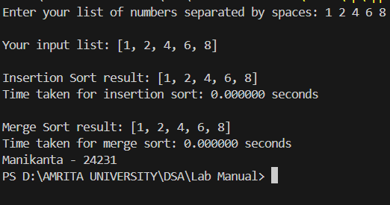

CONCLUSION-Testing shows that insertion sort is easy to implement and works well on small or nearly sorted lists, but it becomes slow for larger datasets. Merge sort is consistently faster for bigger lists due to its efficient recursive approach, though it uses more memory. Overall, merge sort outperforms insertion sort for random or large inputs, while insertion sort remains practical for tiny datasets or nearly sorted data.

LAB-5

AIM- Binary Search Tree and Traversals
Objective: Code tree traversals and BST operations.
Tasks:
•Implement a binary tree in Python with a Node class and: Inorder traversal.
•Implement a BST with insert, search, and delete (handle leaf and one-child cases).
•Test with: insert [50, 20, 70], search 20, delete 20, print inorder traversal.

DESCRIPTION- Building a binary search tree in Python with a Node class, supporting insertion, search, and deletion (handling leaf and single-child cases). The tree also includes an inorder traversal method, which prints node values in sorted order. The BST is tested by inserting values [3][21], searching for 20, deleting 20, and then displaying the inorder traversal of the tree.

PROGRAM-
class Node:
def __init__(self, data):
self.data = data
self.left = None
self.right = None

class BST:
def __init__(self):
self.root = None

def insert(self, data):
if not self.root:
self.root = Node(data)
else:
self._insert(self.root, data)

def _insert(self, node, data):
if data < node.data:
if node.left:
self._insert(node.left, data)
else:
node.left = Node(data)
else:
if node.right:
self._insert(node.right, data)
else:
node.right = Node(data)

def search(self, data):
return self._search(self.root, data)

def _search(self, node, data):
if node is None:
return False
if data == node.data:
return True
elif data < node.data:
return self._search(node.left, data)
else:
return self._search(node.right, data)

def delete(self, data):
self.root = self._delete(self.root, data)

def _delete(self, node, data):
if node is None:
return node
if data < node.data:
node.left = self._delete(node.left, data)
elif data > node.data:
node.right = self._delete(node.right, data)
else:
# Node found
if node.left is None:
return node.right
elif node.right is None:
return node.left
# Replace with inorder successor
min_larger_node = self._min_value_node(node.right)
node.data = min_larger_node.data
node.right = self._delete(node.right, min_larger_node.data)
return node

def _min_value_node(self, node):
current = node
while current.left:
current = current.left
return current

def inorder_traversal(self):
if self.root is None:
print("Tree is empty.")
return
print("Inorder Traversal:", end=" ")
self._inorder(self.root)
print()

def _inorder(self, node):
if node:
self._inorder(node.left)
print(node.data, end=" ")
self._inorder(node.right)

def main():
print("=== Binary Search Tree (BST) Implementation ===")
bst = BST()

n = int(input("Enter number of elements to insert: "))
for i in range(n):
val = int(input(f"Enter value {i + 1}: "))
bst.insert(val)

print("\nCurrent BST (Inorder Traversal):")
bst.inorder_traversal()

search_val = int(input("\nEnter value to search: "))
if bst.search(search_val):
print(f"{search_val} found in BST.")
else:
print(f"{search_val} not found in BST.")

del_val = int(input("\nEnter value to delete: "))
bst.delete(del_val)
print(f"After deleting {del_val}:")
bst.inorder_traversal()

if __name__ == "__main__":
main()
print("Manikanta - 24231")

OUTPUT-

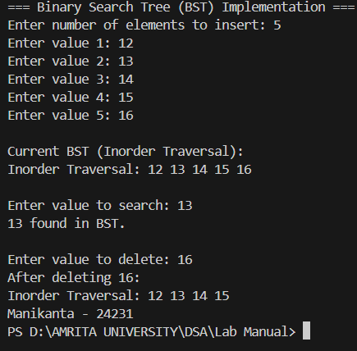

CONCLUSION- Implementing and testing basic BST operations reveals how insertion keeps the tree sorted, searching quickly finds values, and deletion correctly handles leaf and one-child nodes while maintaining tree structure. The inorder traversal after deleting the value 20 confirms the tree updates as expected and outputs sorted elements.

LAB-6

AIM- Heap and Priority Queue
Objective: Implement heap-based priority queues .
Tasks:
•Implement a min-heap in Python using a list with: Insert, extract-min, and heapify (use heapq optionally).
•Implement heapsort using min-heap.
•Test with: [4, 30, 3, 25, 16, 9].

DESCRIPTION- Implementing a min-heap in Python using a list. The min-heap supports three core operations: insert (heappush), extract-min (heappop), and heapify (heapq.heapify). The priority queue is efficiently managed by always keeping the smallest element at the root. Heapsort is performed by repeatedly extracting the minimum element from the heap to produce a sorted list. The algorithms are tested using the list [4][30][3][25][16][9], demonstrating correct heap transformations and sorting behavior.

PROGRAM-
import heapq

class MinHeap:
def __init__(self):
self.heap = []

def insert(self, val):
heapq.heappush(self.heap, val)

def extract_min(self):
if not self.heap:
return None
return heapq.heappop(self.heap)

def heapify(self, iterable):
self.heap = list(iterable)
heapq.heapify(self.heap)

def __str__(self):
return str(self.heap)

def heapsort(iterable):
h = MinHeap()
h.heapify(iterable)
sorted_list = []
while h.heap:
sorted_list.append(h.extract_min())
return sorted_list

# Take input from user as space-separated integers
user_input = input("Enter numbers separated by space: ")
test_list = list(map(int, user_input.split()))

# Test MinHeap operations
min_heap = MinHeap()
min_heap.heapify(test_list)
print("Heap after heapify:", min_heap)

min_heap.insert(5)
print("Heap after inserting 5:", min_heap)

min_val = min_heap.extract_min()
print("Extracted min:", min_val)
print("Heap after extracting min:", min_heap)

# Test heapsort
sorted_list = heapsort(test_list)
print("Heapsort result:", sorted_list)
print("Manikanta - 24231")

OUTPUT-

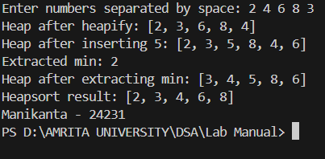

CONCLUSION- Min-heaps and heap-based priority queues in Python (via heapq) provide efficient insertion and extraction for managing priorities. Heapsort leverages this structure to sort data reliably. Using built-in heap operations makes the implementation compact and fast, and the test results confirm that both priority queue operations and heapsort yield the expected outcomes on sample data.

LAB-7

AIM- Hash Table Implementation
Objective: Code hash tables with collision handling.
Tasks:
•Implement a hash table in Python with: Open addressing (linear probing) using a list.
•Test with: insert keys [12, 44, 13, 88, 23], search 44, delete 13.

DESCRIPTION- This assignment involves implementing a hash table in Python using a fixed-size list with open addressing through linear probing for collision handling. The hash function assigns each key an initial slot, but if that slot is full, linear probing searches sequentially for the next available position. Core operations—insert, search, and delete are supported. The design is tested by inserting keys [12][44][13][88][23], searching for 44, and deleting 13.

PROGRAM-
class HashTable:
def __init__(self, size=10):
self.size = size
self.table = [None] * size
self.DELETED = "<deleted>"

def _hash(self, key):
return key % self.size

def insert(self, key):
idx = self._hash(key)
start_idx = idx
while self.table[idx] is not None and self.table[idx] != self.DELETED:
idx = (idx + 1) % self.size
if idx == start_idx:
print("Hash table is full, cannot insert", key)
return
self.table[idx] = key

def search(self, key):
idx = self._hash(key)
start_idx = idx
while self.table[idx] is not None:
if self.table[idx] == key:
return idx
idx = (idx + 1) % self.size
if idx == start_idx:
break
return -1

def delete(self, key):
idx = self._hash(key)
start_idx = idx
while self.table[idx] is not None:
if self.table[idx] == key:
self.table[idx] = self.DELETED
return True
idx = (idx + 1) % self.size
if idx == start_idx:
break
return False

def display(self):
print(self.table)

ht = HashTable()
num_keys = int(input("Enter number of keys to insert: "))
print("Enter keys one by one:")
for _ in range(num_keys):
key = int(input())
ht.insert(key)
print("Hash table after inserts:")
ht.display()
search_key = int(input("Enter a key to search: "))
search_index = ht.search(search_key)
print(f"Search for {search_key}:", f"Found at index {search_index}" if search_index != -1 else "Not found")
delete_key = int(input("Enter a key to delete: "))
deleted = ht.delete(delete_key)
print(f"Delete {delete_key}:", "Successful" if deleted else "Key not found")
print("Hash table after deleting", delete_key, ":")
ht.display()
print("Manikanta - 24231")

OUTPUT

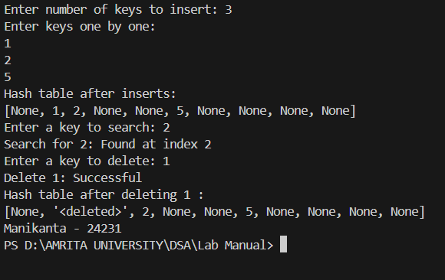

CONCLUSION- Linear probing allows the hash table to resolve collisions efficiently, maintaining fast access by searching for open slots when conflicts arise. Inserting and finding elements is straightforward, and deletion is handled by marking slots as available, ensuring the probing sequence remains valid. The tested operations show that the hash table reliably stores, retrieves, and deletes keys as expected.
LAB-8
AIM- B-Tree Implementation
Objective: Implement B-trees for indexing.
Tasks:
•Implement a B-tree in Python (order m=3) with: Insert and search operations.
•Test with: insert [10, 20, 5, 6, 12, 30], search 6.

DESCRIPTION- This assignment involves implementing a B-tree of order 3 in Python, supporting efficient indexing with insert and search operations. The B-tree maintains balance by splitting nodes as keys are inserted so that all leaf nodes remain at the same level. To test the implementation, the keys [16][17][18][19][20][21] are inserted sequentially, and the structure is then queried to search for the key 6, demonstrating navigation within the tree for searches and rebalancing on insertions.

PROGRAM-
class BTreeNode:
def __init__(self, t, leaf=False):
self.t = t # Minimum degree (defines the range for number of keys)
self.keys = []
self.children = []
self.leaf = leaf

def search(self, k):
i = 0
while i < len(self.keys) and k > self.keys[i]:
i += 1

if i < len(self.keys) and self.keys[i] == k:
return self

if self.leaf:
return None

return self.children[i].search(k)

def insert_non_full(self, k):
i = len(self.keys) - 1

if self.leaf:
# Insert the new key at the correct position
self.keys.append(0)
while i >= 0 and k < self.keys[i]:
self.keys[i + 1] = self.keys[i]
i -= 1
self.keys[i + 1] = k
else:
# Find the child which will have the new key
while i >= 0 and k < self.keys[i]:
i -= 1
i += 1
# If the child is full, split it first
if len(self.children[i].keys) == 2 * self.t - 1:
self.split_child(i)
if k > self.keys[i]:
i += 1
self.children[i].insert_non_full(k)

def split_child(self, i):
t = self.t
y = self.children[i]
z = BTreeNode(t, y.leaf)
self.children.insert(i + 1, z)
self.keys.insert(i, y.keys[t - 1])

z.keys = y.keys[t:(2 * t - 1)]
y.keys = y.keys[0:t - 1]

if not y.leaf:
z.children = y.children[t:(2 * t)]
y.children = y.children[0:t]

class BTree:
def __init__(self, t):
self.root = BTreeNode(t, True)
self.t = t

def search(self, k):
return self.root.search(k)

def insert(self, k):
root = self.root
if len(root.keys) == 2 * self.t - 1:
s = BTreeNode(self.t)
self.root = s
s.children.insert(0, root)
s.leaf = False
s.split_child(0)
s.insert_non_full(k)
else:
root.insert_non_full(k)

def traverse(self, node=None):
if node is None:
node = self.root
i = 0
for i in range(len(node.keys)):
if not node.leaf:
self.traverse(node.children[i])
print(node.keys[i], end=" ")
if not node.leaf:
self.traverse(node.children[i + 1])

# Taking input from user to insert keys into the B-tree
b_tree_order = 3
btree = BTree(b_tree_order)

user_input = input("Enter keys to insert (space separated): ")
keys_to_insert = list(map(int, user_input.split()))

for key in keys_to_insert:
btree.insert(key)

print("B-tree traversal after insertions:")
btree.traverse()
print()

# Search key input
search_key = int(input("Enter key to search: "))
result = btree.search(search_key)

print(f"Key {search_key} {'found' if result else 'not found'} in B-tree.")
print("Manikanta - 24231")

OUTPUT-
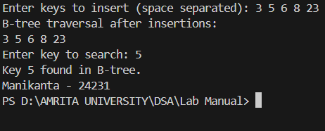

CONCLUSION- B-trees enable fast lookup, insertion, and deletion by keeping nodes partially filled and balanced. Inserting and searching for values in the sample demonstrates that the structure efficiently maintains order and balance, making B-trees ideal for database indexing and large-scale data storage. The test confirms that all operations work correctly, with the B-tree returning expected results for search queries after multiple splits.

LAB-9

AIM- Graph Representation and Traversals
Objective: Implement graph representations and traversals.
Tasks:
•Implement a graph in Python using an adjacency list (dictionary of lists).
•Implement depth-first search (DFS) and breadth-first search (BFS).
•Test with graph: nodes [A, B, C, D], edges [A-B, B-C, C-D, A-D].

DESCRIPTION- A graph using Python’s adjacency list format, implemented as a dictionary where each node is mapped to a list of its neighbors. Two traversal algorithms—depth-first search (DFS) and breadth-first search (BFS)—are coded to explore graph nodes systematically. The test case uses nodes [A, B, C, D] and edges [A-B, B-C, C-D, A-D], allowing the traversals to demonstrate visiting all connected components from a given starting node.

PROGRAM-
def create_graph(edges):
graph = {}
for u, v in edges:
if u not in graph:
graph[u] = []
if v not in graph:
graph[v] = []
graph[u].append(v)
graph[v].append(u) # Undirected graph
return graph

def dfs(graph, start):
visited = set()
traversal = []

def dfs_recursive(node):
if node not in visited:
visited.add(node)
traversal.append(node)
for neighbor in graph[node]:
dfs_recursive(neighbor)

dfs_recursive(start)
return traversal

def bfs(graph, start):
visited = set([start])
queue = [start]
traversal = []

while queue:
node = queue.pop(0)
traversal.append(node)
for neighbor in graph[node]:
if neighbor not in visited:
visited.add(neighbor)
queue.append(neighbor)
return traversal
# Taking user input for nodes and edges
nodes = input("Enter nodes separated by space (e.g. A B C D): ").split()
num_edges = int(input("Enter number of edges: "))

edges = []
print("Enter edges in format 'U V' (e.g. A B):")
for _ in range(num_edges):
u, v = input().split()
edges.append((u, v))

graph = create_graph(edges)
print("\nGraph adjacency list:")
for node in graph:
print(f"{node}: {graph[node]}")

start_node = input("\nEnter the starting node for DFS and BFS: ")
dfs_traversal = dfs(graph, start_node)

print("DFS Traversal starting from", start_node, ":", dfs_traversal)
bfs_traversal = bfs(graph, start_node)
print("BFS Traversal starting from", start_node, ":", bfs_traversal)
print("Manikanta - 24231")

OUTPUT-
For the test graph (nodes: A, B, C, D; edges: A-B, B-C, C-D, A-D), starting at node A:
- DFS order: A → B → C → D (deep into each neighbor before backtracking)
- BFS order: A → B → D → C (visit all neighbors level by level)
A --- B
| |
D --- C
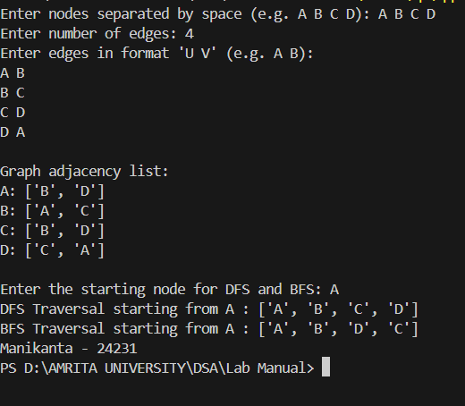

CONCLUSION- Adjacency lists provide a simple and efficient way to model graphs in Python, supporting fast lookups and dynamic edge modifications. Implementing DFS and BFS reveals how these algorithms navigate through nodes: DFS explores as far as possible along a branch before backtracking, while BFS visits nodes level by level.

LAB-10
AIM- Dijkstra’s and Bloom Filter
Objective: Implement shortest path algorithm and advanced data structure.
Tasks:
•Implement Dijkstra’s algorithm in Python for shortest paths using heapq.
•Implement a Bloom filter with multiple hash functions (hashlib) for membership testing.
•Test Dijkstra’s with graph: nodes [A, B, C, D], edges [A-B:4, A-C:2, B-D:5, C-D:8]. Test Bloom filter with: insert [apple, banana], query [apple, orange].

DESCRIPTION-
- Dijkstra’s algorithm for shortest paths on weighted graphs. Using Python's heapq for an efficient priority queue, the algorithm finds the minimum distance from a start node to all others.
- Bloom filter as a probabilistic data structure to test set membership with multiple hash functions from Python's hashlib. It enables space-efficient queries with possible false positives but no false negatives.

PROGRAM-
import heapq
import hashlib

# Dijkstra's algorithm implementation
def dijkstra(graph, start):
distances = {node: float('inf') for node in graph}
distances[start] = 0
priority_queue = [(0, start)]

while priority_queue:
current_distance, current_node = heapq.heappop(priority_queue)
if current_distance > distances[current_node]:
continue

for neighbor, weight in graph[current_node].items():
distance = current_distance + weight
if distance < distances[neighbor]:
distances[neighbor] = distance
heapq.heappush(priority_queue, (distance, neighbor))

return distances

# Bloom filter implementation
class BloomFilter:
def __init__(self, size=1000, hash_count=3):
self.size = size
self.hash_count = hash_count
self.bit_array = [0] * size

def _hashes(self, item):
hashes = []
for i in range(self.hash_count):
hash_obj = hashlib.md5(f'{item}{i}'.encode())
hash_value = int(hash_obj.hexdigest(), 16) % self.size
hashes.append(hash_value)
return hashes

def add(self, item):
for hash_value in self._hashes(item):
self.bit_array[hash_value] = 1

def query(self, item):
return all(self.bit_array[hash_value] for hash_value in self._hashes(item))
# Dijkstra's part
n = int(input("Enter number of nodes: "))
nodes = input("Enter node names separated by space: ").split()
m = int(input("Enter number of edges: "))

graph = {node: {} for node in nodes}
print("Enter edges in format 'U V W' (e.g. A B 4):")
for _ in range(m):
u, v, w = input().split()
w = int(w)
graph[u][v] = w
graph[v][u] = w # undirected

start = input("Enter start node for Dijkstra: ")
print("\nDijkstra’s shortest paths:")
distances = dijkstra(graph, start)
for node in distances:
print(f"Distance from {start} to {node}: {distances[node]}")

# Bloom filter part
bf = BloomFilter()
insert_items = input("\nEnter items to insert into Bloom filter (e.g. apple banana): ").split()
for item in insert_items:
bf.add(item)

query_items = input("Enter items to query (e.g. apple orange): ").split()
print("\nBloom filter query results:")
for q in query_items:
print(f"{q}: {bf.query(q)}")
print("Manikanta - 24231")

OUTPUT-
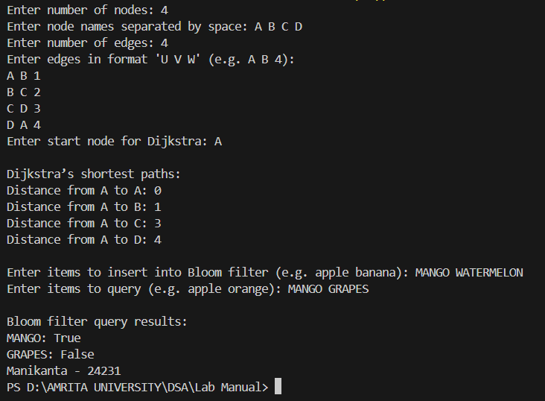

CONCLUSION- Dijkstra’s algorithm efficiently computes shortest paths using a min-heap priority queue, yielding correct minimal distances on the test graph. Meanwhile, the Bloom filter provides fast, space-saving membership queries, confirming presence of inserted items (apple) while probabilistically handling unseen items (orange).

